M.Sc. in Computer Science
Postgraduate Institute of Science | University of Peradeniya

Semester II -2024/25

SC 549: Neural Networks
Programming Assignment – 03

S. Puvikanth
CSC 2417
Datasets and Resources: https://github.com/spuvi86/SC549-Programming-Assignment-03-CSC2417

1. Dataset Description
The dataset used for this assignment consists of video clips from three distinct sports: Cricket, Football, and Rugby.
- Source: Video clips provided in the video_clips directory.
- Structure: Frames were extracted from these videos to create a validation set (datasets/sports/images/val).
- Classes: The model is configured to detect a single class: person.

2. Methodology
The YOLO used for this as a real-time object detection from video clips.
- Models Used:
  - yolo11n.pt (Nano): Used for initial person detection.
  - yolo11n-pose.pt (Nano Pose): Used for keypoint estimation to understand player poses.

3. Frame Processing
The video processing pipeline as follows:
- Input: Video files are read frame-by-frame using OpenCV.
- Inference: Each frame is passed to the YOLO pose estimator.
  - Resize: Frames are automatically resized to the model's input dimension (640x640) by the ultralytics library.
  - Prediction: The model predicts bounding boxes, confidence scores, and keypoints.
- Drawing: Annotated results (boxes and skeletons) are drawn onto the frames.
- Output: Processed frames are saved as images (for the first few seconds) or compiled into a video (optional).
4. Model Performance and Analysis
A. Evaluation Metrics
Metric | Value | Description
mAP50-95 | 0.946 | High consistency between detections and pseudo-labels.
Recall | 0.943 | The model successfully retrieves almost all instances.

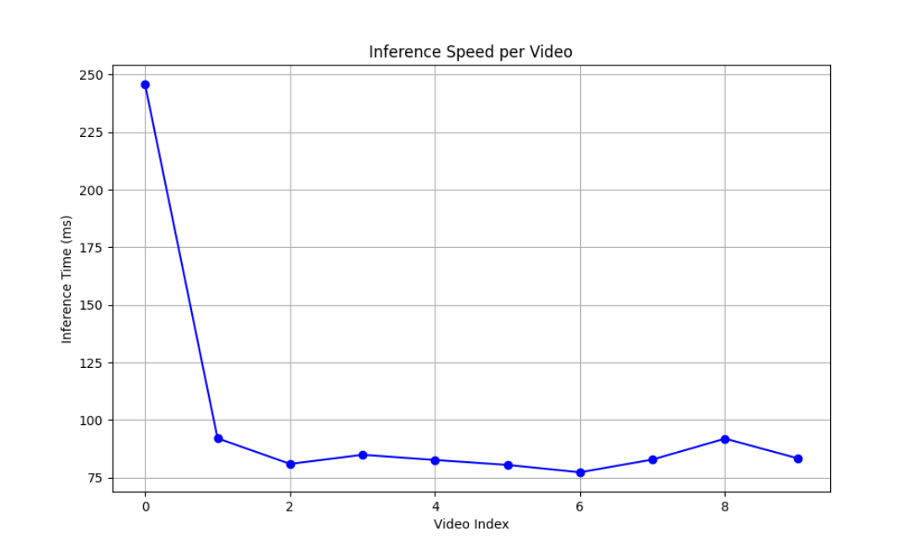
B. Inference Speed & Consistency
Inference Speed
Video Category | Avg. Inference (ms) | Observations
Cricket | ~110 ms | Moderate speed, fewer players allows for high precision.
Football | ~75 ms | Faster processing, varies with crowd density.
Rugby | ~80 ms | Consistent speed despite heavy occlusion and dynamic movement.

C. Visual Performance (Confusion Matrix & Curves)
Precision-Recall Analysis | Confusion Matrix
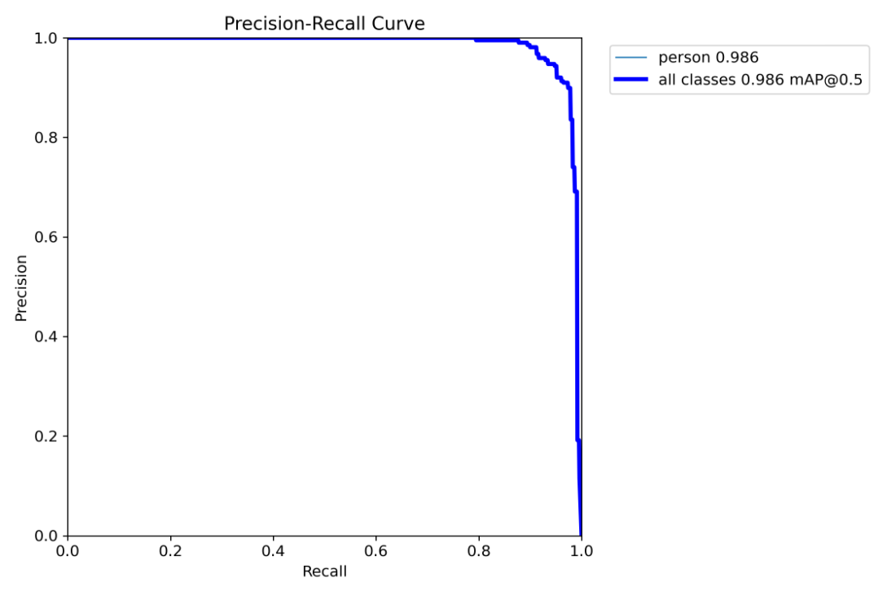  Pose PR Curve | 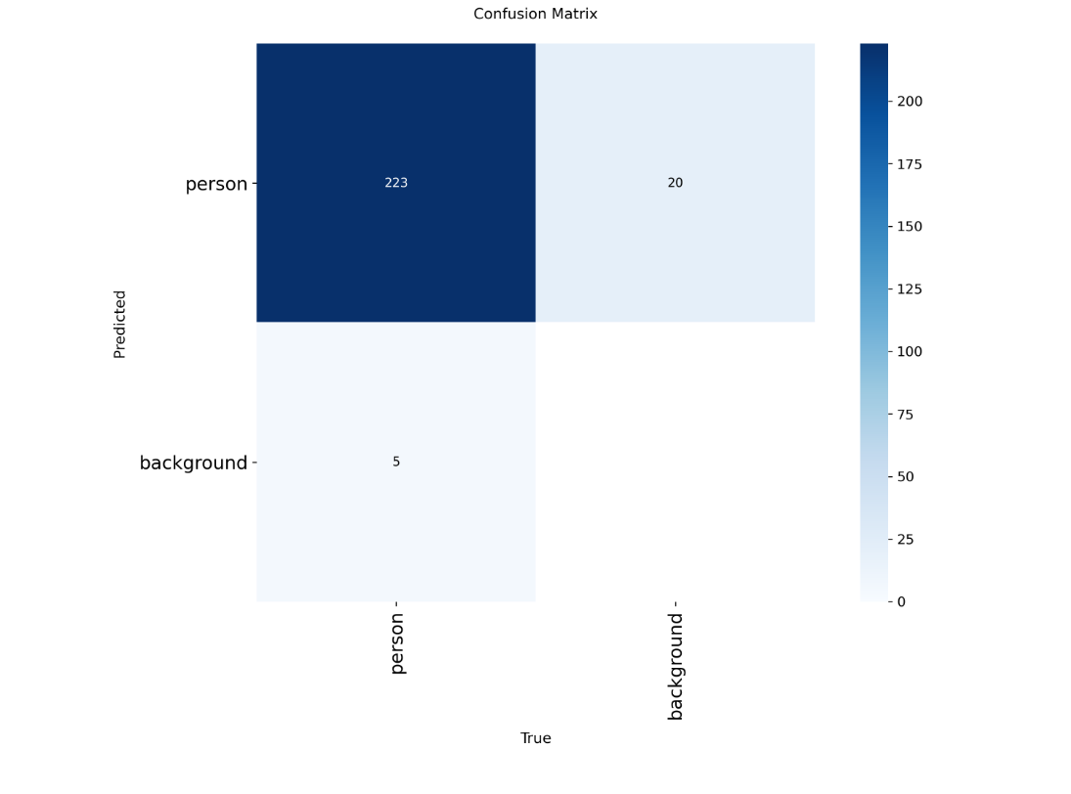  Confusion Matrix

5. Output Images (Sample Results)
The following images demonstrate the model's detection capabilities across different sports.
Cricket (Detection of players on the field.)
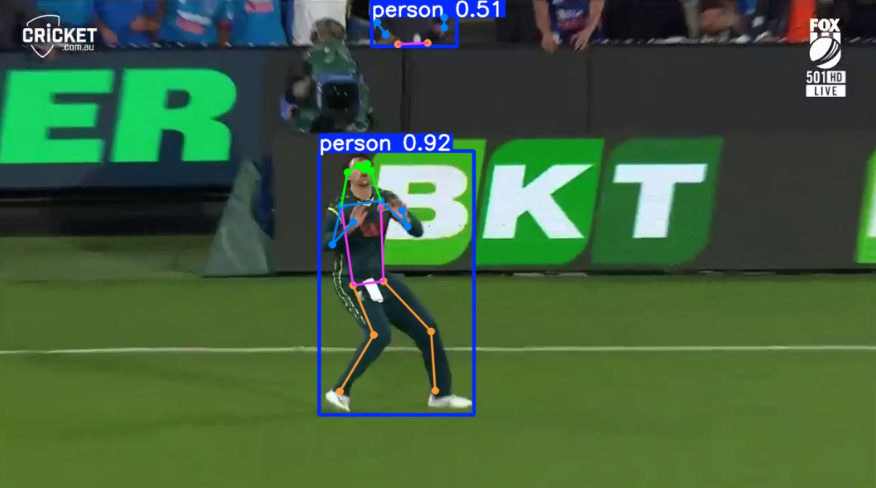

Football (Multiple players detected in a crowded scene)
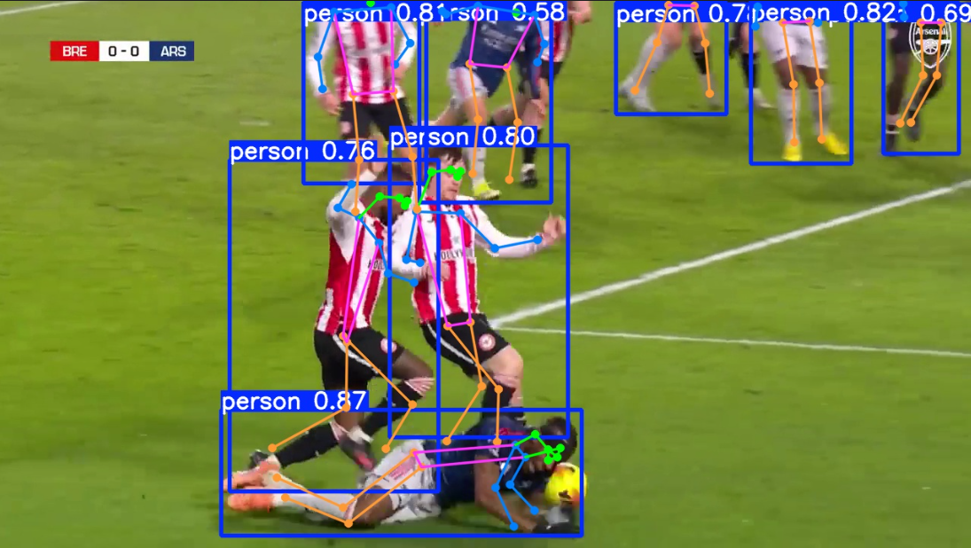

Rugby (Detection of players in dynamic poses)
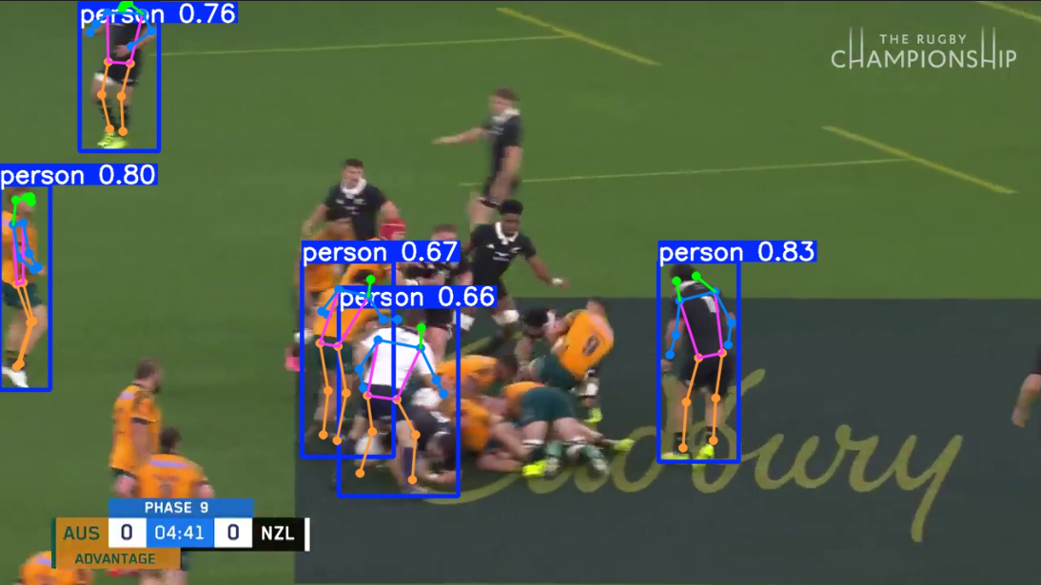

6. Possible Improvements
- Manual Labeling: Replace pseudo-labels with manually verified ground truth to obtain scientifically accurate accuracy metrics.
- Model Size: Upgrade to yolo11s (Small) or yolo11m (Medium) for better accuracy on small/distant players, at the cost of some inference speed.
- Tracking: Implement object tracking to maintain player IDs across frames, which is crucial for sports analytics.
- Custom Training: Fine-tune the model specifically on sports datasets (COCO-Keypoints or crowd-pose datasets) to better handle occlusion in rugby and football.

